With the increase in the demand for oil, the storage of underground oil is decreasing. With the increasing difficulty of mining, the cost of mining is also much higher than before. In order to cut costs, Sunco companies can only find ways to reduce expenses from the transportation side. Sunco is Oil extraction company produces oil to Los Angeles and New York which have largest oil demand in the United states. Sunco produces oil at two wells. Well 1 can produces up to 150000 barrels per day, and well 2 can produce up to 200,000 barrels per day. In terms of transportation, there are two types of transportation routes for Sunco Oil to choose from. First is to ship oil directly from the wells to Sunco’s customers in Los Angeles and New York. Second, Sunco could transport oil to the ports of Mobile and Galveston and then ship it by tanker to New York or Los Angeles. In terms of demand, Los Angeles requires 160,000 barrels per day, and New York requires 140,000 barrels per day. The costs of shipping 1000 barrels between various locations are shown in the file P05_55.xlsm, where a blank indicates shipments that are not allowed, since the road condition between that two areas cannot meet the safety requirement of oil transition. Determine how to minimize the transport costs in meeting the oil demands of Los Angeles and New York.

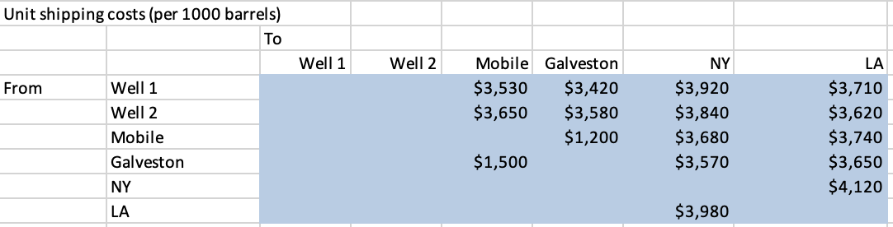

Discussion

This is a network programming model. The objective is to minimize the transport costs in meeting the oil demands of Los Angeles and New York. We should decide how many nodes that we need base on the given constrains. For example, let well 1, well2, M, G, NY, and LA as nodes 1,2,3,4,5, and 6 respectively. Due to blank indicates shipments that are not allowed, we need create network which is not include those blank nodes in excel model. In network programming model, we also need consider the outflow and inflow factors. Each outflow or inflow have to consider about each node’s capacity. Warehouse is special node, which represents the node in or out is always equal to 0. Determined all the constrains, then use a modified shipping model to find the optimal solution.

Model solution attached in Ex55[Sunco]_S excel file.